# 0. Side menu category

## 0.1 Category menu

* **Side menu category consists of (before login)**
* **LOGIN**
* **HOME**
* **NEW**
* **BEST**
* **WOMEN**
* **MEN**
* **BRAND**
* **COLLECTION**
* **COMMUNITY**
* **SALE**
* **EVENT**
* **Side menu category consists of (AFTER login)**
* **LOGOUT**
* **HOME**
* **NEW**
* **BEST**
* **WOMEN**
* **MEN**
* **BRAND**
* **COLLECTION**
* **COMMUNITY**
* **SALE**
* **EVENT**
* **If you press the side menu bar, the menu will appear from left to the right side - 60% of the screen is occupied. (the sidebar disappears when you press X or the remaining 40% blank screen)**

# 1. Product display policy

## 1.1 Main page

* Contents of main page are flexible. There are 5 types of contents layouts, and all the layouts can be arranged by its usage. **Sample default layouts : main banner - new product - brand banner - best product - event - hot sale zone - KCLIVE contents.**
* **Layout type 1**

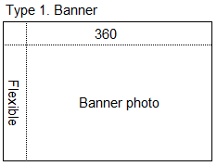

- required information are contents ID, type code, Image URL, destination, priority.

- contents ID consists of “10” + 8 numbers.

- width is fixed : 360, length is flexible.

- maximum 5 banners can be added.

- horizontal swipe funciton for banner section.

- destination URL should be linked to the banner.

- Youtube video format should be available on banner section.

- prioirty should be set : 1 ~ 6, same numbers are not allowed.

* **Layout type 2**

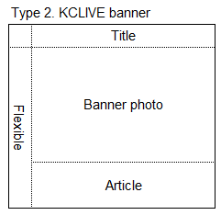

- required information are contents ID, type code, title, Image URL, destination, description, priority.

- contents ID consists of “20” + 8 numbers.

- width is fixed : 360, length is flexible.

- title should be set.

- maximum 5 banners can be added.

- horizontal swipe funciton for banner section.

- when user clicks the contents section, show detail contents with pop-up display.

- Youtube video format should be available on banner section.

- maximum 3 lines are visible on article area, and show detail contents with pop-up display.

- prioirty should be set : 1 ~ 6, same numbers are not allowed.

* **Layout type 3**

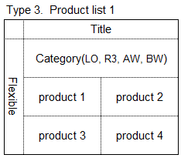

- required information are contents ID, type code, title, product ID, image URL, destination, priority.

- contents ID consists of “10” + 8 numbers.

- n*2 form. Row is flexible, column is fixed : 2 column.

- title should be set (such as best products, new products)

- 4 categories : LO, R3, AW, BW

- when user clicks the category, show the products of each category.

- horizontal swipe function allowed for category section.

- vertical swipe function allowed for product section.

- if there are more than 2 rows, product section spreads

- photo or video can be added on product section (2 rows combined or 2 columns combined)

- Youtube video format should be available on product section.

- prioirty should be set : 1 ~ 6, same numbers are not allowed.

* **Layout type 4**

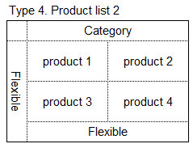

- required information are contents ID, type code, category, row, column, image URL, destination, priority.

- contents ID consists of “30” + 8 numbers.

- n*2 form. Row is flexible, column is fixed : 2 column.

- category should be set (such as pants, t-shirts)

- vertical swipe function allowed for product section.

- if there are more than 2 rows, product section spreads

- photo or video can be added on product section (2 rows combined or 2 columns combined)

- Youtube video format should be available on product section.

- prioirty should be set : 1 ~ 6, same numbers are not allowed.

* **Layout type 5**

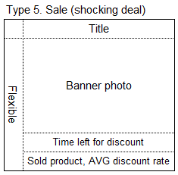

- required information are contents ID, type code, title, image URL, destination, priority.

- contents ID consists of “10” + 8 numbers.

- width is fixed : 360, length is flexible.

- title should be set.

- only 1 banner can be added.

- when user clicks the contents section, move to sale detail screen.

- Youtube video format should be available on banner section.

- time left for discount is displayed, day/hour/minute/second

- quantity of sold product and AVG discount rate are displayed.

- prioirty should be set : 1 ~ 6, same numbers are not allowed.

* **Layout type 6**

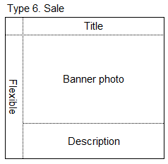

- required information are contents ID, type code, title, Image URL, destination, description, priority.

- contents ID consists of “10” + 8 numbers.

- width is fixed : 360, length is flexible.

- title should be set.

- maximum 5 banners can be added.

- horizontal swipe funciton for banner section.

- when user clicks the contents section, move to sale detail screen.

- Youtube video format should be available on banner section.

- maximum 3 lines are visible on article area, and show detail contents with pop-up display.

- prioirty should be set : 1 ~ 6, same numbers are not allowed.

* **The items displayed on the main page include the following information.**
* **Brand name**

Brand name of each product is indicated (ex. LIMEORANGE, AFTER WORK, RHYMEORANGE)

* **product name**

The product name is displayed. (ex. Power stretch jean, Air hoodie, Stripe shirt)

* **Item code** - **Display the item code of the item (Product code: 2 alphabets + 8 numbers + 2 color code alphabets + 1 size code alphabets = total 13)**

WO18784578-DBL, same color code only Moving directly to another color in detail page

* **price**

Price is displayed. (When a sale is applied, the prices before and after the application are displayed together, and the prices before the application are displayed in gray and the prices are displayed in a line.)

## 1.2 Product detail page

* **Product detail page refers to a page the users can see when they click the product on the main page.**
* **The product detail page contains the following information.**
* **Product thumbnail photos** – If there are more than one photos, users can swipe or click button to see the next photo.
* **Product name** - The name of the product or collection name
* **Hash tag** - A hash tag (ex. #airun #woman #UV)
* **Price** - The price of the item (When the sale is applied, the price before and after the discount is displayed together. Price before discount – gray color font with lined price. Price after discount – green color font with bold)
* **Go to Review button** - Click to go directly to the review corner.
* **Product Code**
* **Shipping Policy button** - Show shipping policy (Ex : 15,000 for Ho Chi Minh City and free for over 180,000. 30,000 for other areas, and free for over 360,000)
* **Select color** - Color selection



* **Select size** – Size selection



* **Membership rate button** – Press the button to display detailed information (eg ORANGE: 3%, LIME: 5%, VIP: 7%, VVIP: 10%)
* **Size Chart Button** – Size chart by gender and cloth category

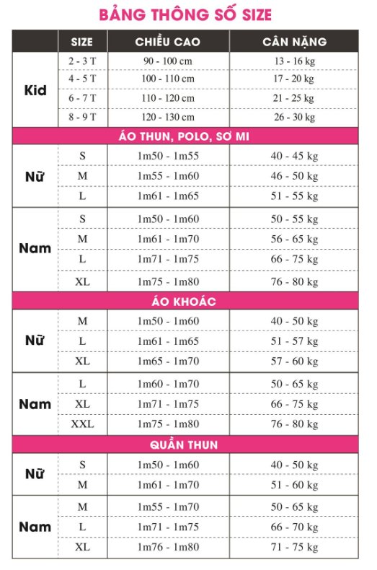

* **Offline inventory check** – shows how many products are in stock in each store.
* **Online stock notification** – When sold out products are restocked, send notification to the customers.
* **Product option information and price confirmation** - After choosing color and size, finalize product detail information and price confirmation.
* **Order button** – Press the button to move to order detail page
* **Favorite items** - List the favorite items and display pop-up messages. Show how many people set as a favorite item.

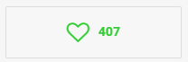

* **Product related notice** - Important notice related to shipping, order, and mileage point.

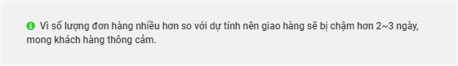

* **Product Facebook share** – Product information share function on Facebook.
* **Related products** - Display related products.
* **Product image detail** - Product image detail.
* **Reviews** - Reviews for the items.
* **Q & A** - Questions about the product.
* **Exchange & Refund Info** - Display exchange and refund information for the item.

## 1.3 Product list page

* Product list page consists of
* Category navigation – Users can move to another category using navigation.
* Display total number of products.
* Product display form is same as main page, 2 rows, 8 columns, total 16 products, pagination.
* Product arrangement – New product, best product, low price to high price, high price to low price.

## 1.4 New page

* Two categories : Women’s new product, men’s new product, each category has see more button.
* Divided by genders, 2 rows and 4 columns, 8 items, total 16 items(women, men) display.
* Click see more button to go to the new product list of the gender.
* How to sort your items when you click on see more button and go to new product list. New product, best product, low price to high price, high price to low price.

## 1.5 BEST page

* Two categories : Women’s best product, men’s best product, each category has see more button.
* Divided by genders, 2 rows and 4 columns, 8 items, total 16 items(women, men) display.
* Click see more button to go to the new product list of the gender.
* How to sort your items when you click on see more button and go to best product list. New product, best product, low price to high price, high price to low price.

## 1.6 Women’s product

* All women's products, display the brand of each product.
* Categories : AO THUN, QUAN JEANS, QUAN & VAY, DAM, AO SO MI & AO KIEU, AO KHOAC, PHU KIEN
* Product display method is the same as main page.
* Sorting products - New products, best products, Low to high price, high to low price

## 1.7 Men’s product

* All men's products, display the brand of each product.
* Categories : AO THUN, QUAN JEANS, QUAN & VAY, DAM, AO SO MI & AO KIEU, AO KHOAC, PHU KIEN
* Product display method is the same as main page.
* Sorting products - New products, best products, Low to high price, high to low price

## 1.8 UNISEX product

* Categories : AO KHOAC, AO THUN, QUAN, PHU KIEN
* Product display method is the same as main page.
* Sorting products - New products, best products, Low to high price, high to low price

## 1.9 BRAND

* Brand consists of LO BASIC, R3, AW, BW tab
* Click each brand to go to the brand shopping page
* Side categories for each brand’s shopping page :

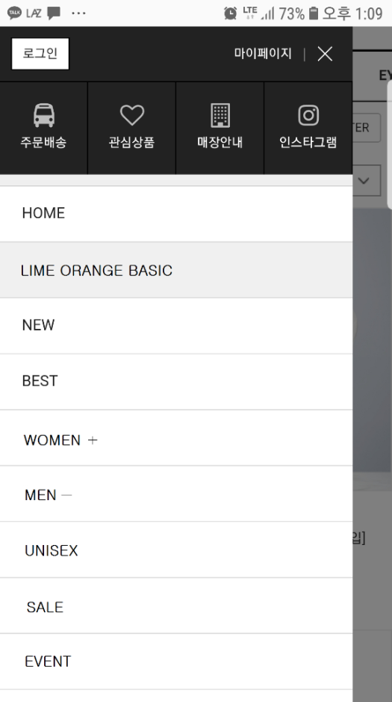

## 1.9.1 BRAND (LO BASIC)

* Three categories : women, men, unisex.
* Women category consists of AO THUN, QUAN JEANS, QUAN & VAY, DAM, AO SO MI & AO KIEU, AO KHOAC and PHU KIEN.
* Men category consists of AO THUN, AO SO MI, AO KHOAC, QUAN JEANS, QUAN PANTS & QUAN KAKI and PHU KIEN.
* UNISEX category consists of AO KHOAC, AO THUN, QUAN and PHU KIEN.
* SALE is a brand sale
* EVENT is a brand event

## 1.9.2 BRAND (R3)

* Three categories : women, men, unisex.
* Women category consists of AO KHOAC, AO THUN, QUAN, PHU KIEN
* Men category consists of AO KHOAC, AO THUN, QUAN, PHU KIEN
* UNISEX category consists of AO KHOAC, AO THUN, QUAN, PHU KIEN
* SALE is a brand sale
* EVENT is a brand event

## 1.9.3 BRAND (AW)

* Three categories : women, men, unisex.
* Women category consists of AO KHOAC, AO THUN, DAM, VAY, QUAN JEAN, PHU KIEN.
* Men category consists of AO KHOAC, AO THUN, QUAN, PHU KIEN.
* UNISEX category consists of AO KHOAC, AO THUN, QUAN, PHU KIEN.
* SALE is a brand sale
* EVENT is a brand event

## 1.9.4 BRAND (BW)

* Three categories : women, men, unisex.
* Women category consists of AO KHOAC, AO THUN, QUAN, PHU KIEN
* Men category consists of AO KHOAC, AO THUN, QUAN, PHU KIEN
* UNISEX category consists of AO KHOAC, AO THUN, QUAN, PHU KIEN
* SALE is a brand sale
* EVENT is a brand event

## 1.10 Collection page

* Collection pages consist of four categories – total collection, LO BASIC, R3, AW
* When you go to the collection page, it shows the collection banner, name and registration date.
* When the users click collection banner, display collection item (same as product detail page)
* Sorting products - New products, best products, Low to high price, high to low price

## 1.11 Hot sale zone page(for shocking deal and happy weekend)

* The Hot Sale Zone is the page for Shocking Deal and Happy Weekend events.
* On the main page, Hot Sale Zone Banner displays total sales quantity, average discount rate, remaining time for the sale by days, hours, minutes and seconds
* If the users click Hot Sale Zone banner of see more button, show Hot Sale Zone detail page.
* Product detail page of Hot Sale Zone is the same as the previous one (show remaining time for saying) - No Related products, reviews, FAQ, Q & A.
* Hot Sale Zone Detail page consists of the following.

• One product on one screen

• Discounted price and price before discount - Show price before discount

• Show the quantity of the products sold, discount rate, remaining time left for sale by days, hours, minutes, seconds.

• Out of stock items go to the bottom of the page